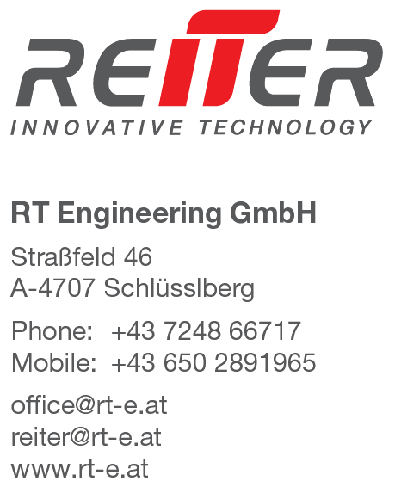

Press release Sima 2017

New generation of pick-up rake
Slim, elastic, six-row, camless, gentle and powerful at the same time - these are the remarkable attributes of the new Respiro pick-up technology. The start-up company Reiter Innovative Technology presents for the first time at Agraria the new revolutionary elastic pick-up.
The small, six-rowed and camless pick-up lifts all crops gently and without contamination. A spine made of spring steel allows the elastic deformation of the pick-up yoke. Four freely rotating skids guide the elastic collector exactly above ground. The ground contact by the pick-up tines is thus reduced to an absolute minimum.

The simple attachment of the tines is impressive: with a single M8 screw, six double tines are attached. It's that easy. The special feature of this anti-loss system is that the tine coils are supported perfectly. A loss of the tines is practically impossible. The mounting of the tines is very simple.
The drive of the pick-up is carried out centrally by means of a lifetime-lubricated gearbox. The double bearings left and right are maintenance-free. There is not a single grease nipple on the pick-up. The simple design of the pick-up, the generously dimensioned bearings and the well-distributed support distances suggest a high degree of robustness. Elastic units can yield and thus damp the impact peaks. According to the manufacturer, this should significantly increase the service life of the unit.

Due to its very small diameter, the crop is lifted particularly gently from the ground. This will mainly help to reduce the loss of leaf and crumbling. Impressive is also the performance: without compromising on the quality of raking, the pick-up system can be used up to 25 km / h - provided the field conditions permit it. As a rule of thumb: with the Respiro one can swath as fast as mowing.
It remains to be seen whether this new generation of pick-up technology will also find its way into harvesting technology such as balers, loading wagons or choppers. The outside wheels are then superfluous, the actual raking width can be increased to 2.5 m for balers and loading wagons. The small diameter also has the charm that the material flow is fed to the rotor quickly without any significant deflection. This allows high performance.

You can find this text and the corresponding picture material on the homepage at:
www.rt-e.net/press

For further questions, please contact Mr. DI Thomas Reiter
Mobile: 0043/650 28 919 65 email: reiter@rt-e.at

